Level 4 -> Level 5

The goal of this level is to find the pass to log into <http://natas5.natas.labs.overthewire.org>.

Username: natas5

After logging into level 4 we got a message that **“Access disallowed. You are visiting from “**[**http://natas4.natas.labs.overthewire.org/index.php**](http://natas4.natas.labs.overthewire.org/index.php)**” while authorized users should come only from** [**http://natas5.natas.labs.overthewire.org**](http://natas5.natas.labs.overthewire.org) **””** and also a refresh button is given but we are unable to do anything.

In this task we need to somehow change our request url (referer) from <http://natas4.natas.labs.overthewire.org/index.php> to <http://natas5.natas.labs.overthewire.org>. We can do it using **Burp suit**.

So, I switched to kali linux. Inserted foxy proxy in my firefox and intercepted the request in burp suit. The snapshot below shows the intercepted request.

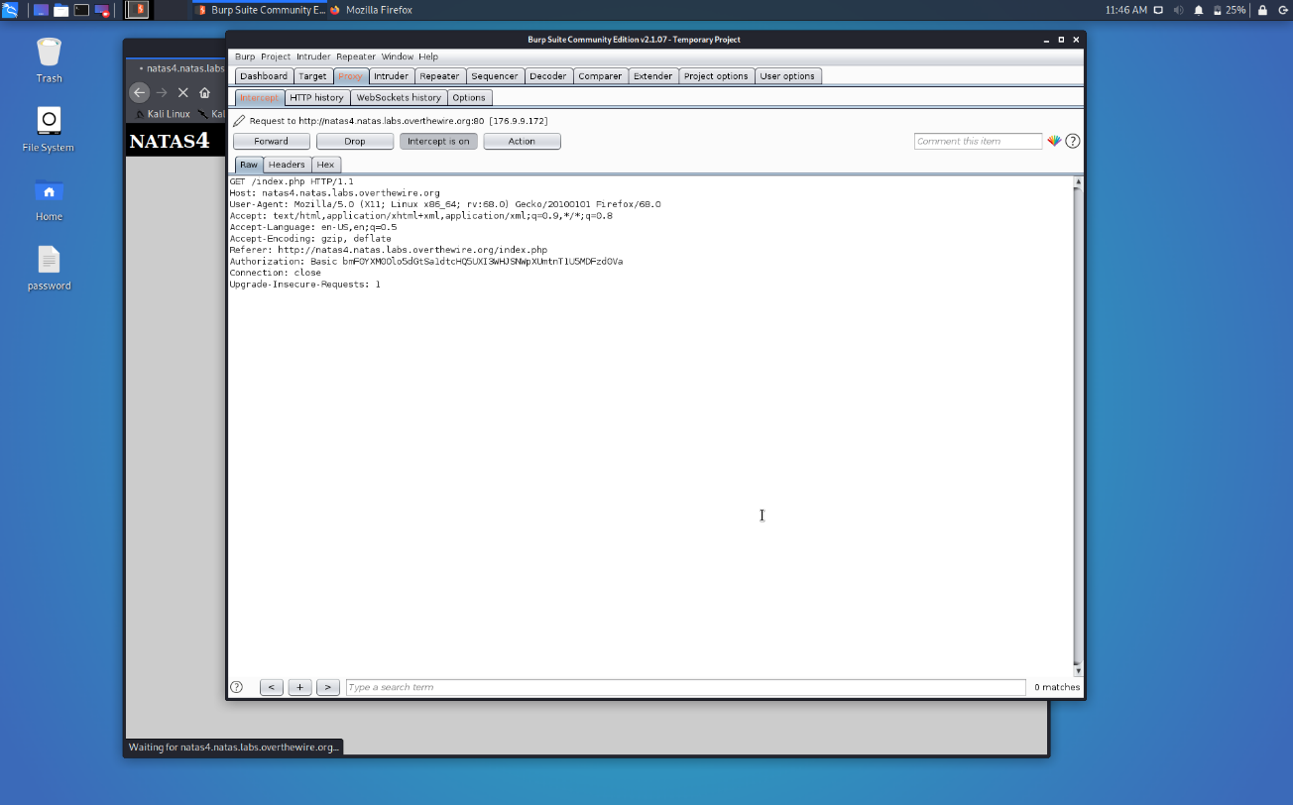

What I will do is simply change the **referer** to the required url and forward the request.

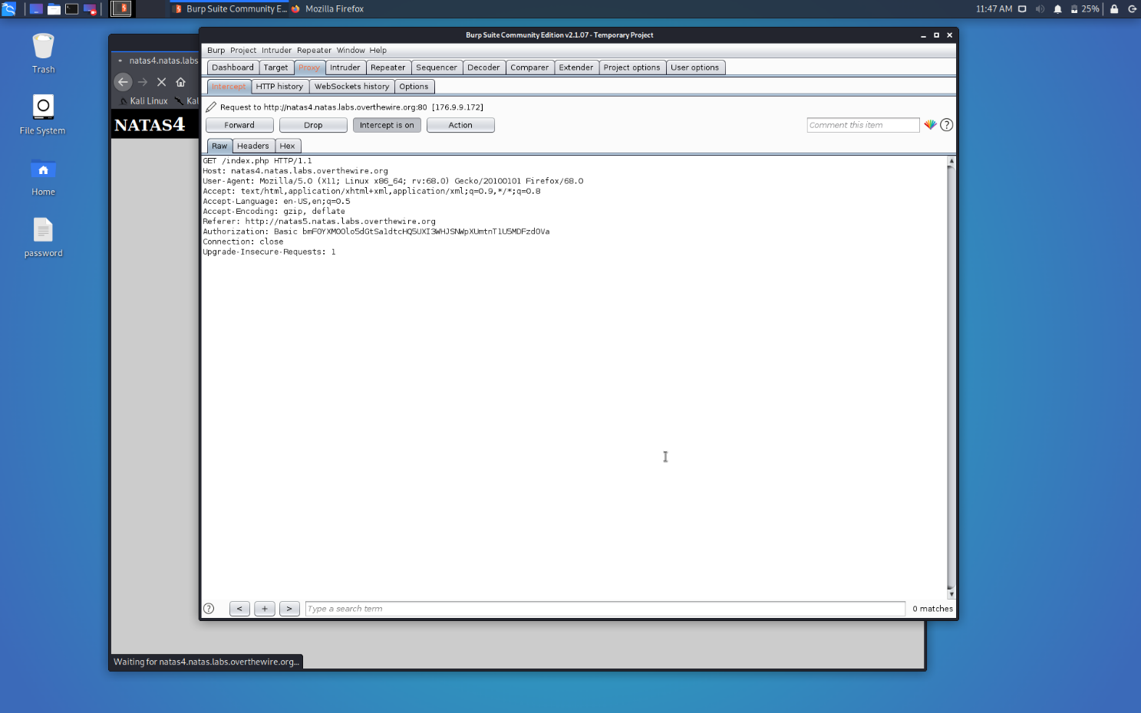

As soon as we will forward the request we are successfully logged in Natas4 and got the password to the next level at it’s home page only.

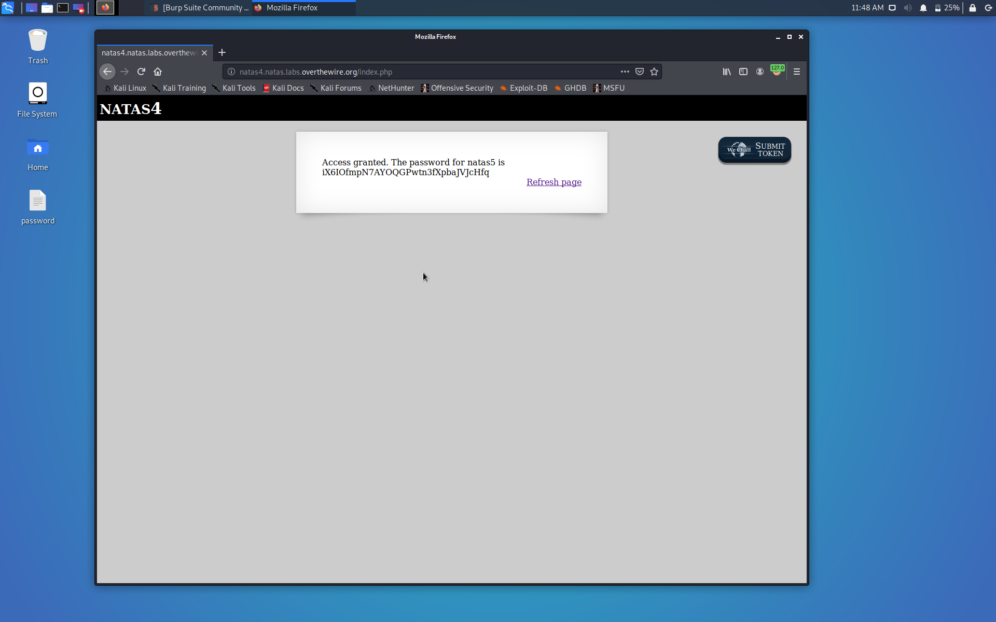

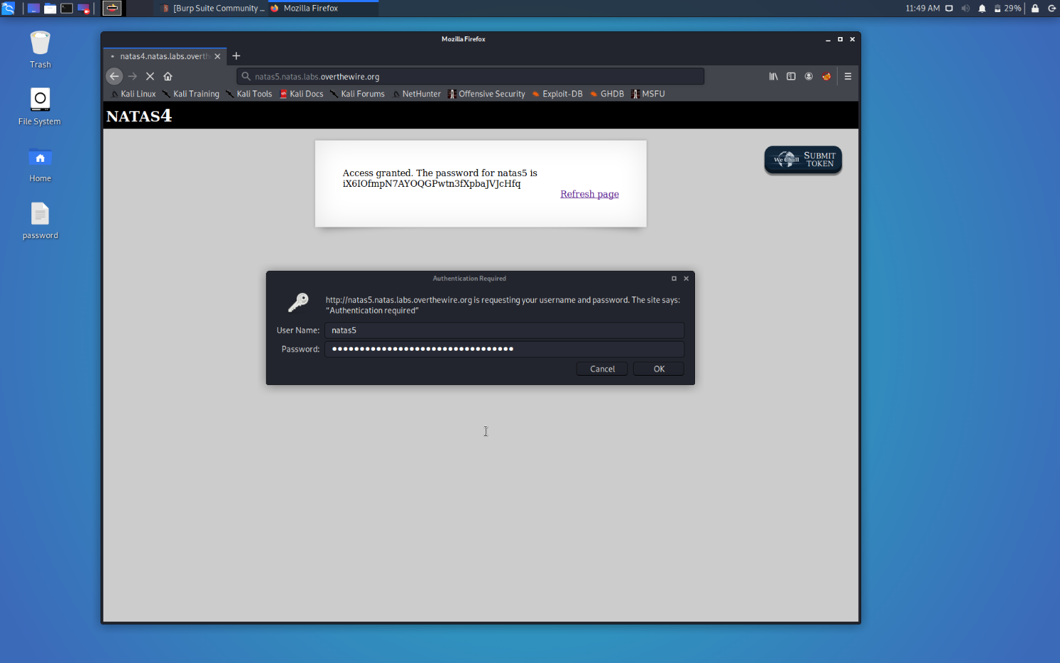

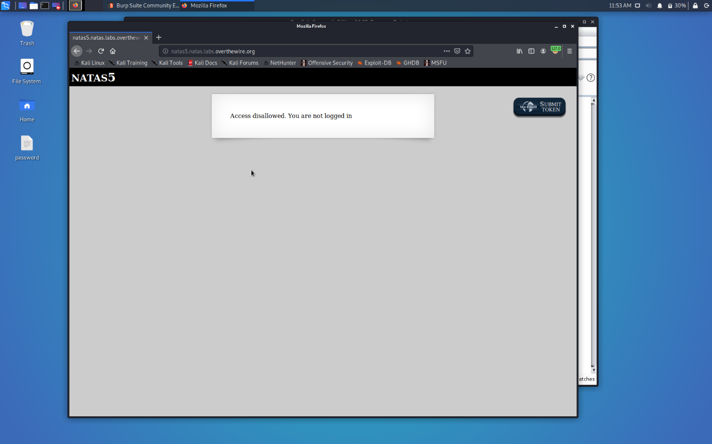

Successfully passed level 5.…